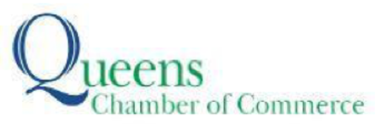

*Press Contact:*

Nasreen Hussain

nasreen@anatgerstein.com, (347) 853-2980

**FOR IMMEDIATE RELEASE**

March 24, 2025

**Tom Grech, President and CEO of the Queens Chamber Of Commerce, Issues Statement on the Cancellation of Forest Hills Stadium’s 2025 Concert Season**

QUEENS, NY (March 24, 2025) - Tom Grech, President and CEO of the Queens Chamber of Commerce, the borough’s oldest and largest business association, issued the following statement in response to the cancellation of Forest Hills Stadium’s 2025 concert season:

*“The decision to deny Forest Hills Stadium the necessary permits to host its summer concert series is nothing short of a travesty—one that will have severe economic and cultural consequences for Forest Hills and beyond. For more than a decade, Forest Hills Stadium has been a catalyst for economic growth, a steward of our community, and a world-class venue that has brought joy to thousands. Shutting it down for the summer is an enormous loss for local businesses, the hundreds of workers who rely on the stadium for jobs, and the concertgoers who make Forest Hills a destination.*

*Let’s be clear: a small, vocal group has derailed what has otherwise been a model of partnership and goodwill. Their refusal to engage in good faith has put the livelihoods of working people at risk and stripped Forest Hills of one of its most cherished institutions. The idea that a handful of individuals can wield this kind of outsized influence to the detriment of an entire neighborhood is both outrageous and unacceptable.*

*Forest Hills Stadium has done everything right. In addition to being open to meeting with neighbors expressing concern, they have worked hard to support local organizations, preserve its historic legacy, and invest in the neighborhood. Now, the stadium needs our support. The Queens Chamber of Commerce stands firmly with Forest Hills Stadium, its workers, and the small businesses that depend on it. We urge city officials and all stakeholders to work toward a resolution that allows this iconic venue to continue serving our community.”*

**About the Queens Chamber of Commerce:**  
The Queens Chamber of Commerce is the oldest and largest business association in Queens, representing more than 1,400 businesses and more than 150,000 Queens-based employees. Its mission is to foster connections, educate for success, develop/implement programs and advocate for members’ interests. [www.queenschamber.org](http://www.queenschamber.org)

**###**