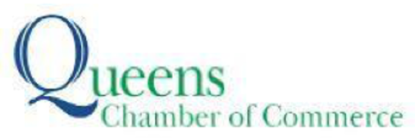

Contact: Nasreen Hussain,

nasreen@anatgerstein.com, (347) 853-2980

For Immediate Release

**QUEENS CHAMBER OF COMMERCE AND HUNDREDS OF BUSINESS LEADERS VISIT THE STATE CAPITOL FOR QUEENS DAY IN ALBANY**

*NYS Assembly Speaker Carl E. Heastie delivered remarks at A Taste of Queens, as Chamber*

*members met with dozens of members of the Queens Assembly and State Senate delegations*

***For photos,*** [***click here***](https://www.dropbox.com/scl/fo/0z6ikog83qj4hexdjm7vg/h?dl=0&rlkey=8yfeg87m4bruvetyacczkrmn9)*(Photo Credit: Dominick Totino)*

QUEENS, NY (May 5, 2023)—On May 2, hundreds of business leaders from Queens visited

Albany to meet with their legislators as the Queens Chamber of Commerce hosted its annual Queens Day in Albany. The annual event gives local business leaders the opportunity to advocate for the interests of businesses in the state capitol. Chamber members met with dozens of members of the State Senate and Assembly, then enjoyed lunch while NYS Assembly Speaker Carl E. Heastie delivered remarks at a reception called “A Taste Of Queens,” featuring the culinary talents of more than 40 restaurants from across the borough.

“Small businesses of all types from across the borough play an important role in keeping our communities a wonderful and diverse place to live and work,” said **Tom Grech, President and CEO of the Queens Chamber of Commerce.** “Advocating for our members is an essential part of what we do and that includes meeting with our elected officials face to face and ensuring they not only hear about the successes of our local business owners, but the challenges they face as well. I want to thank all the business leaders who took time out of their schedules to come with us today, and all the elected officials who met with them during the final day of budget negotiations.”

During meetings with elected officials, Chamber members brought up several issues from the Chamber’s 2023 Legislative Agenda that impact businesses in Queens and throughout New York State. For the legislative agenda, [click here](https://www.dropbox.com/scl/fo/0z6ikog83qj4hexdjm7vg/h?dl=0&rlkey=8yfeg87m4bruvetyacczkrmn9).

**About the Queens Chamber of Commerce:**

The Queens Chamber of Commerce is the oldest and largest business association in Queens, representing more than 1,400 businesses and more than 150,000 Queens-based employees. Its mission is to foster connections, educate for success, develop/implement programs and advocate for members’ interests. [www.queenschamber.org](http://www.queenschamber.org/)

###